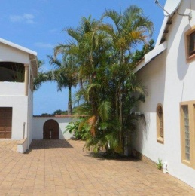
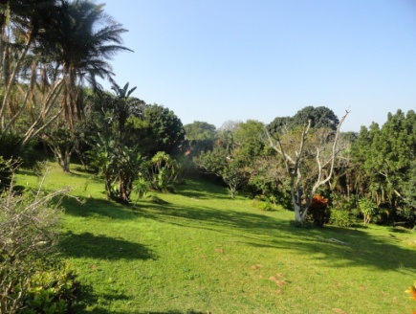
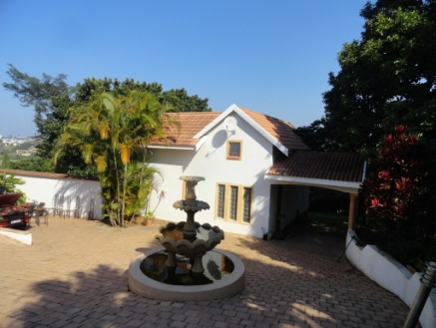

THE BRIGHT ACADEMY PROVIDES TRAINING AND A SAFE HOME BASE FOR FIELD ACTIVITIES AND ATTACHMENTS. USERS MUST BE COMMITTED TO ACTIVITIES THAT ARE/WILL SOON
BE USEFUL FOR SOUTHERN AFRICAN PATIENTS/CLIENTS/STUDENTS OR HEALTH PRACTICES

The BRIGHT Cottage in Shelly Beach, KwaZulu-Natal can hold up to 6 people. Rent includes:
- Shared bedroom/family
- Bathrooms, kitchenette, crockery, access to beautiful garden
- Walking distance from beach and Shelly Beach Mall
- Internet
- Weekly clean: sheets, bathrooms, cleared floors /surfaces
- Use of swimming pool mornings and afternoons
- Fenced parking for up to 3 vehicles
- Alarm and panic buttons

Responsibilities
1. A refundable deposit of ZAR 2000 per person
2. Each person must sign for house rules and secure behaviour.
Unsafe behaviour may result in termination of lease with immediate effect.
3. For a small fee per wash personal laundry can be done.
4. No smoking or braai inside/under roof
5. Provide exact arrival and departure times.

Contact BRIGHT-CBTHR:
sliegagai@hotmail.com, e.f.kjetland@medisin.uio.no, pavipillay10@gmail.com
+27 39 315 1282 (landline)
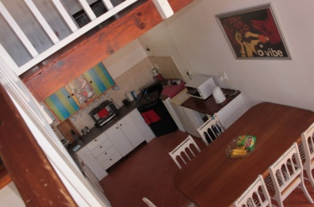
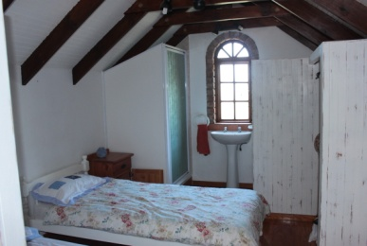
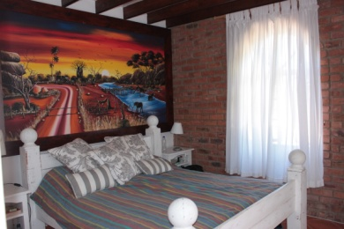
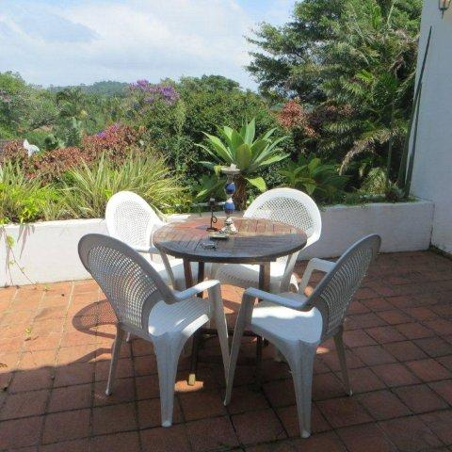
+27 78 406 2558 / +47 9700 8579 (cell phones)

